Registration for the 4th Young AGErs Symposium 2019 at Maastricht University

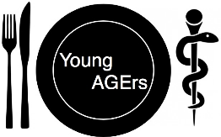
When?:
11-12 April, 2019

Where?:
Maastricht University Medical Centre, NL

Important Dates:
Registration deadline: 15th February 2019
Abstract deadline: 15th March 2019

Personal information (fill in for registration):
Name (first and last name):

University / Department:

E-mail:

Give 5 – 10 key words that describe your research topic:

Questions / suggestions:

